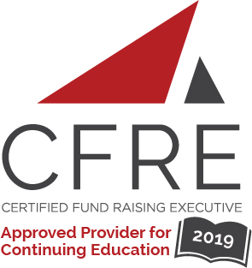
CFRE International has developed this form as a way for you to quickly track (and keep in your files!) the continuing education sessions you have attended. Simply check the boxes next to the sessions you attended. At the end of the conference, add up the total number of hours. Keep this sheet and you will be ready to complete your application form. All of the session slots listed are eligible for continuing education points on your CFRE application for initial certification and/or recertification. Sessions not listed here are not eligible for points.

CONTINUING EDUCATION POINTS TRACKER

Activity Organizer: - AFP Quebec Chapter

Date: January 15, 2019
Session: 3:00 pm – 4:30 pm (1.5 pts)
- Building a strong prospect pipeline and creating great habits
Presented by Jennifer Williams, CFRE

Date: January 16, 2019
Session: 8:00 am– 5:30 pm (8.0 pts)
- CFRE Refresher Course
Presented by Jennifer Williams, CFRE and Alexis Gaiptman, CFRE

Date: February 20, 2019
Session 1: 4:00 pm – 5:30 pm (1.5 pts)
- PANEL : Multiplier son potentiel de collecte de fonds grâce au bénévolat
Par Nancy Dossous, Alain Raymond et Dominic Gagnon

Date: March 28, 2019
Session: 8:30 am– 4:30 pm (7.0 pts)
- Ateliers de « Storytelling »
Par Kim Fuller, Debbie Hynes, Julien Deschamps Jolin et Isabelle Kolish Dufresne

Date: April 9, 2019
Session: 9:00 am– 10:30 am (1.5 pts)
- From Good To Great: Success Fundamentals For Your Major Gift Program
Par Guy Mallabone

Date: May 2, 2019
Session 1: 12:00 pm – 1:30 pm (1.5 pts)
- Capital Campaigns: Gift Tables and Case Statements and Interviews - OH MY!
Par Martha Schumacher

Date: May 23, 2019
Session 1: 12:30 pm – 2:00 pm] (1.5 pts)
- The Philanthropic Sector: What will tomorrow bring?

Date: June 5, 2019
Session 1: 9:00 am – 10:30 am (1.5 pts)
- LAUNCHING A GIFT IN WILLS PROGRAM
Par Ligia Peña, CFRE, MInstF

Date: June 13-14, 2019
Session: 8:00 am– 5:30 pm (15 pts)
- Fundamentals of Fundraising Course

Date: September 12, 2019
Session : 12:30 pm – 13:30 am (1 pt)
- Anatomy of a Gift: The Story of McGill’s $200M Donation
Par Marc Weinstein

Date: October 23, 2019
Session : 12:00 pm – 14:00 am (2 pts)
- Femmes et CA : une bonne décision d’affaires
Par E.Alves, C.Codsi, M.Fequiere et E. Leschiutta

Total number of points attained: __________

